**Noise Pollution Monitoring** **Project Design and Innovation**

**Table of Contents**

| 1 | Introduction |
| --- | --- |
| 2 | Problem Statement |
| 3 | Design and Innovation Strategies |
| 3.1 | Advanced Sensor Technology |
| 3.2 | IoT Integration |
| 3.3 | Data Analytics and Machine Learning |
| 3.4 | Noise Mapping |
| 3.5 | Community Engagement |
| 3.6 | Noise Source Identification |
| 3.7 | Real-time Alerts and Notifications |
| 3.8 | Regulatory Measures |
| 3.9 | Public Awareness Campaigns |
| 3.10 | Collaboration and Partnerships |
| 3.11 | Incentives for Noise Reduction |
| 3.12 | Long-term Planning |
| 3.13 | Data Privacy and Security |
| 3.14 | Feedback Mechanism |
| 3.15 | Continuous Improvement |
| 4 | Conclusion |

**1.Introduction**

The objective of this document is to provide an in-depth analysis of the design and innovation strategies for the Noise Pollution Monitoring. Noise pollution is a growing concern in urban and industrial areas. The adverse effects of excessive noise on human health, well-being, and the environment are well-documented and this project aims to utilize innovative approaches for the development of a comprehensive noise pollution monitoring system.

**2. Problem Statement**

Noise pollution poses significant challenges to both urban residents and environmental agencies. The primary objective of this project is to create a noise monitoring system capable of:  
  
- Real-time noise level measurements.  
- Data storage and analysis.  
- Generating noise pollution reports.  
- Identifying noise sources and patterns.

By achieving these goals, we aim to provide valuable insights that can inform policies and actions to reduce noise pollution.

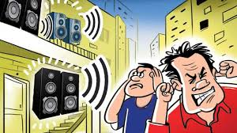

**3. Design and Innovation Strategies**

**3.1. Advanced Sensor Technology:**

- Develop and deploy advanced noise sensors that are capable of accurately measuring noise levels in real-time. These sensors should be cost-effective, durable, and capable of capturing data at various frequencies and decibel levels.

**3.2. IoT Integration:**

- Utilize the Internet of Things (IoT) to create a network of interconnected noise sensors. These sensors can transmit data to a central database, allowing for comprehensive and real-time monitoring of noise pollution levels.

**3.3. Data Analytics and Machine Learning:**

- Implement data analytics and machine learning algorithms to process the vast amounts of data collected by the sensors. These algorithms can help identify patterns, trends, and sources of noise pollution, enabling more targeted mitigation efforts.

**3.4. Noise Mapping:**

- Create noise maps that visualize noise pollution levels across different areas. These maps can help policymakers and urban planners make informed decisions about land use, transportation, and zoning regulations.

**3.5. Community Engagement:**

- Involve local communities in noise pollution monitoring efforts. Crowdsourcing data through mobile apps and community-based noise monitoring programs can provide valuable data and raise awareness about the issue.

**3.6. Noise Source Identification:**

- Develop technology to identify and classify sources of noise pollution, such as traffic, industrial activities, construction, and nightlife. This can help prioritize noise reduction efforts.

**3.7. Real-time Alerts and Notifications:**

- Implement a system for issuing real-time alerts and notifications to residents and relevant authorities when noise pollution levels exceed acceptable limits. This can be done through mobile apps, text messages, or other communication channels.

**3.8. Regulatory Measures:**

- Advocate for and enforce noise pollution regulations and standards. Use the collected data to identify areas where noise levels consistently exceed acceptable limits and take appropriate regulatory actions.

**3.9. Public Awareness Campaigns:**

- Launch public awareness campaigns to educate people about the health and quality of life impacts of noise pollution. Encourage responsible noise behavior and noise reduction practices.

**3.10. Collaboration and Partnerships:**

- Collaborate with universities, research institutions, environmental organizations, and government agencies to share data, research findings, and resources for noise pollution monitoring and mitigation.

**3.11. Incentives for Noise Reduction:**

- Provide incentives for businesses and individuals to reduce noise pollution, such as tax breaks for noise-reducing technologies or construction practices.

**3.12. Long-term Planning:**

- Integrate noise pollution monitoring into long-term urban planning and infrastructure development. Consider noise mitigation measures when designing new transportation systems, residential areas, and industrial zones.

**3.13. Data Privacy and Security:**

- Ensure that data collected from noise sensors is protected, and privacy concerns are addressed. Develop clear guidelines for data sharing and storage.

**3.14. Feedback Mechanism:**

- Establish a feedback mechanism for residents to report noise complaints and concerns, allowing for a responsive approach to addressing noise issues.

**3.15. Continuous Improvement:**

- Continuously update and improve the noise pollution monitoring system based on feedback, technological advancements, and changing noise patterns in urban environments.

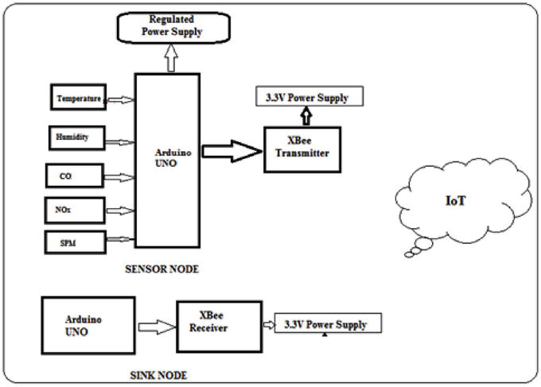

**4. Conclusion**

In conclusion, noise pollution monitoring and management can greatly benefit from innovative strategies and technological advancements. By leveraging sensor technology, IoT, AI, and data analytic, we can collect, analyze, and act upon noise pollution data more effectively. This allows us to create actionable insights, raise public awareness, and collaborate with various stakeholders to reduce the adverse effects of noise pollution on public health and quality of life.